Take a look at the before & after, read story below
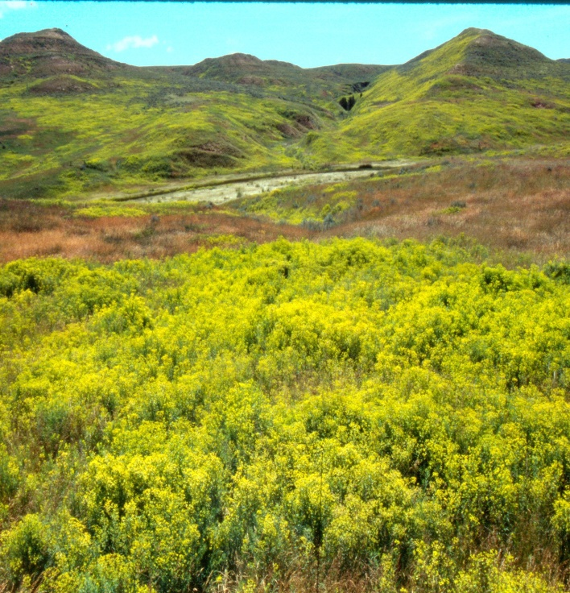 | 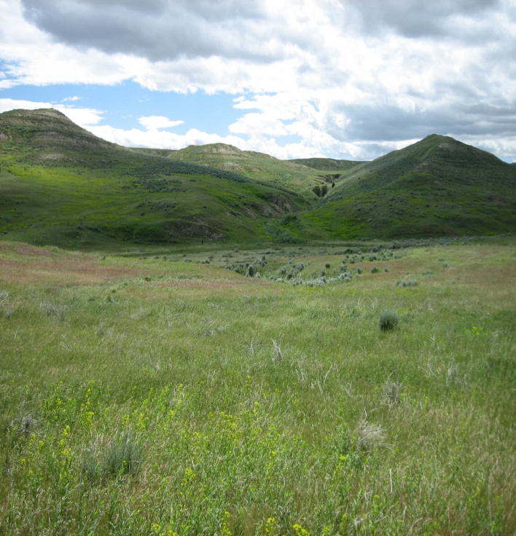
Before | After
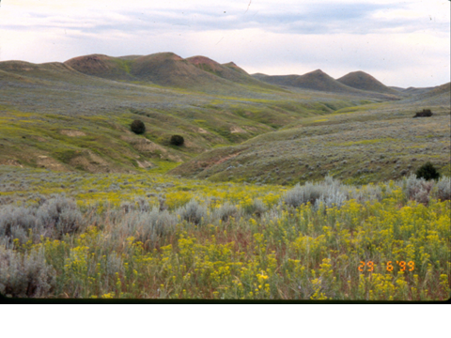 | 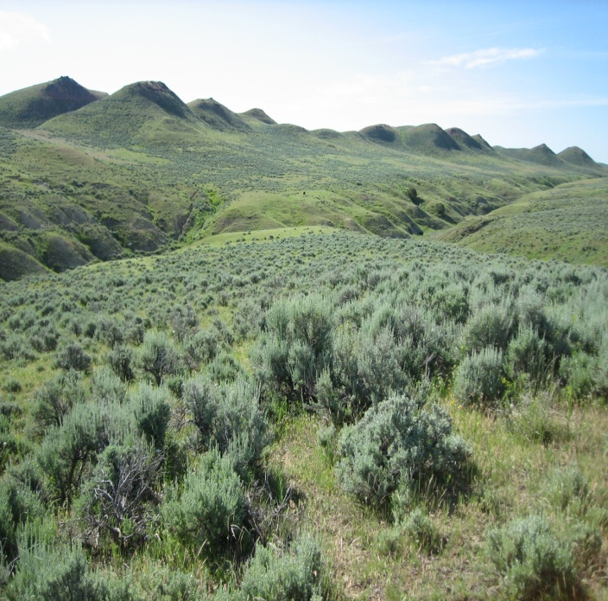
Before | After
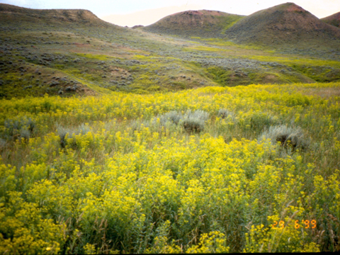 | 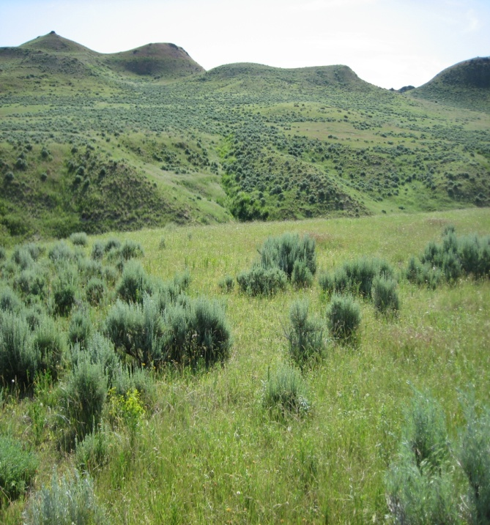
Before | After
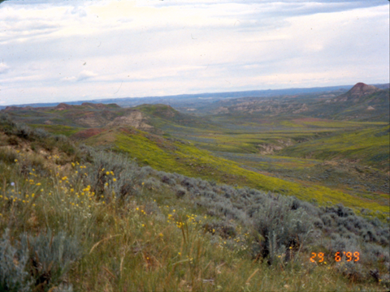 | 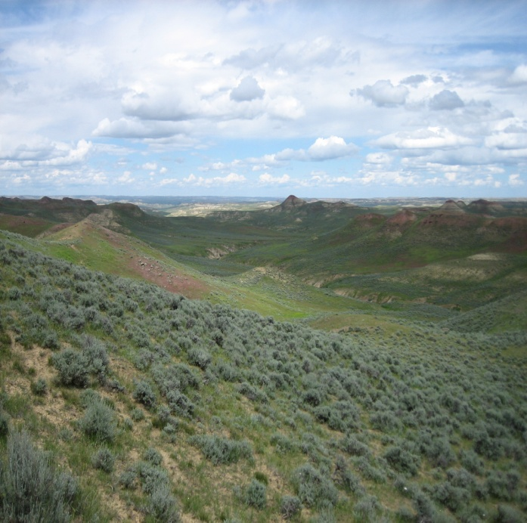
Before | After
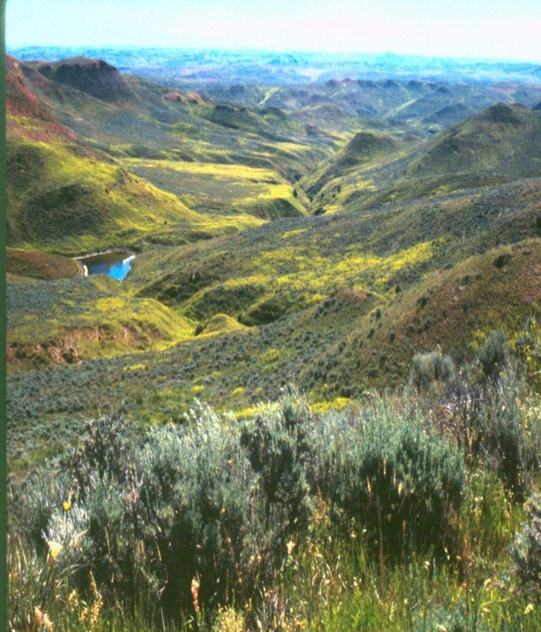 | 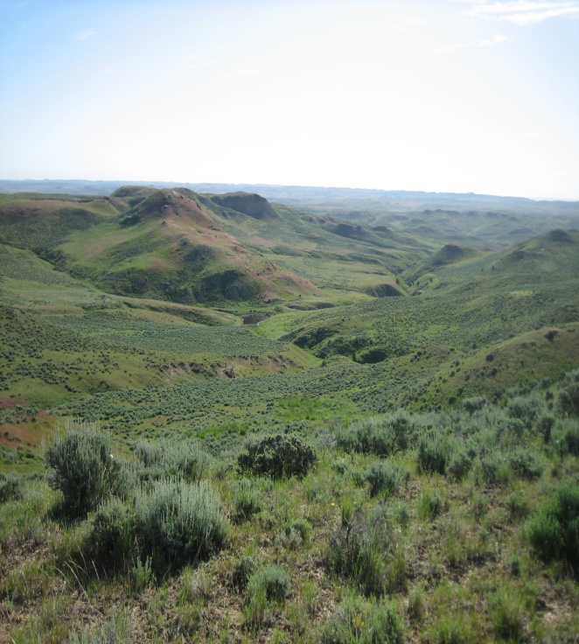
Before | After
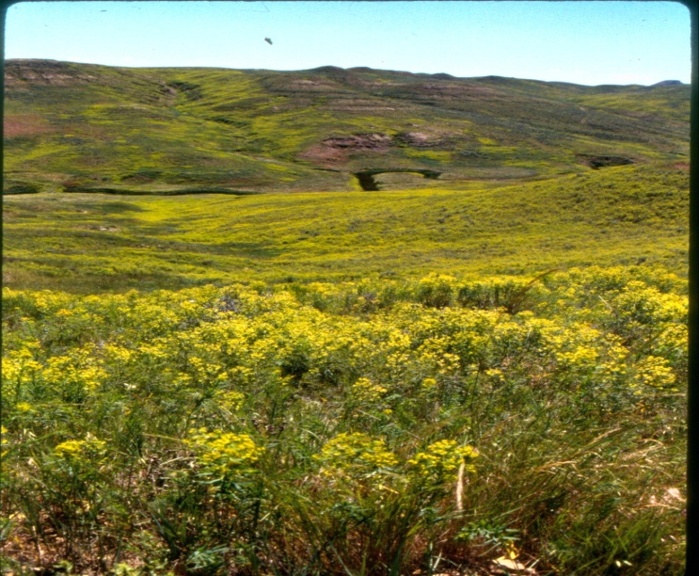 | 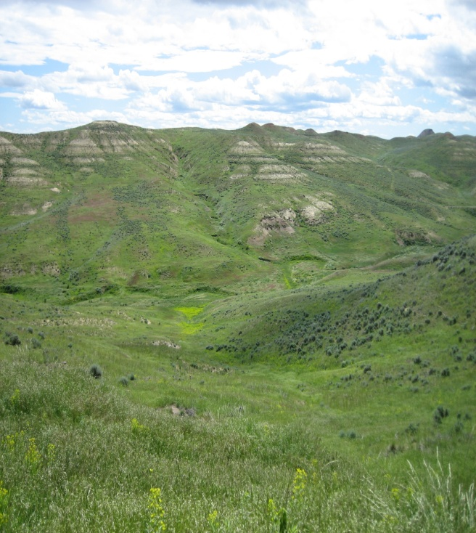
Before | After
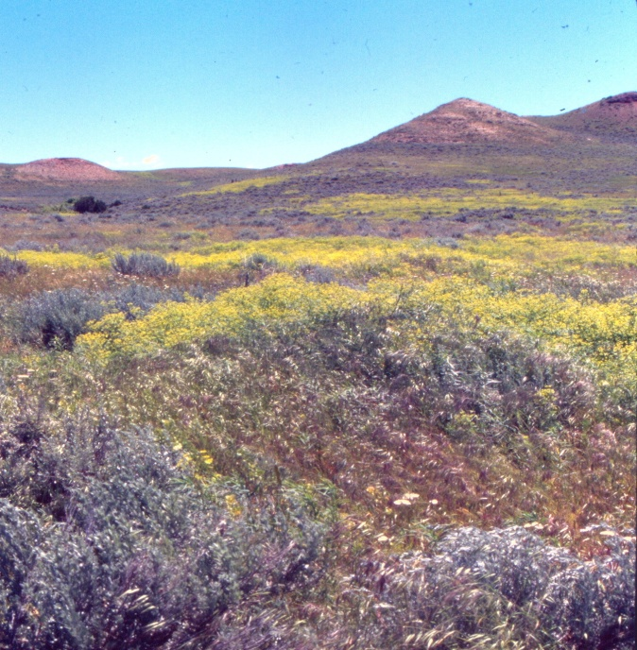 | 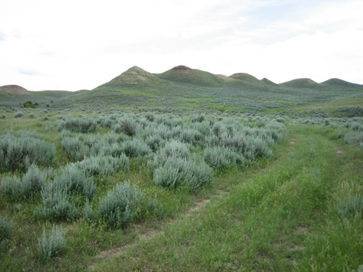
Before | After
Double Crossing Leafy Spurge Management
The District and the participating landowners in the Double Crossing watershed had been continually frustrated with expanding leafy spurge infestations despite thousands of dollars and several years of effort. Basically our spurge program was a disaster. After a meeting with area cooperators in the late 1990’s, the District Board decided it was time to reevaluate the treatment philosophies and attempt to launch a new direction for leafy spurge management. The new management scheme centered on a multiyear commitment from the landowners in the watershed and shift treatments from a higher herbicide one shot rate every few years to lower rates over sequential years. Also pivotal to the program was focusing more time, money and energy into treating the heaviest infested areas so as to slow down the overwhelming spread. While treating new, insipient or scattered infestations is and always will be important, we felt we had lost sight of what was causing that and we were spending too much of our resources basically chasing our tail.
At the same time, the District was cooperating with the local NRCS to allow these same landowners to enroll in an Environmental Quality Incentive Program (EQIP) that provided incentive monies for the landowner to participate in Integrated Pest Management Practices for the control of Leafy Spurge. The goal of this program was to give landowners the tools necessary for proper and sustainable stewardship of the properties so as to optimize their spurge control efforts. Qualifying projects included: fencing and water development for improved livestock management, sagebrush control in select areas, “out of the box” herbicide treatments, bio-control using goat grazing, bio-control using insect collection and distribution and integrating all these practices across a landscape. The incentive payments for each participant were then phased out after three years.
The first treatments under this new vision, with the first three participants, occurred in 2002. There were 10 participating landowners in the Double Crossing watershed with the final year of the EQIP portion of the program occurring in 2006. The above photos reflect that time frame. Most of these landowners continue to participate in the District’s Leafy Spurge program to manage their spurge. This is critical so as to keep the spurge manageable and not let it get out of hand as it was before the program started. These same landowners deserve a tremendous amount of credit for their patience, commitment, determination and having an open mind to change their mindset on how leafy spurge was managed. We no longer view treatment of spurge as control but managing for it in a landscape. In other words, while we would like to see it all gone, it is ok to have some of it in the system. Gone are the days of expensive heavy herbicide treatment rates that suppressed the grass, and killed other valuable forbs and sagebrush, especially when the spurge would reinvade within 3 years along with kochia and cheatgrass. We learned that by using the lighter rates in sequential treatments we could suppress the spurge so that the other forbs, sagebrush and most importantly the grass could flourish and actually compete against leafy spurge. Again, by allowing landowners to develop water and strategically fence their properties under the EQIP program, they could more effectively graze to maximize that competitive edge. Today, we still have leafy spurge in the Double Crossing watershed but it continues to be managed by the landowners with spot treatments as necessary, widely distributes insects and some goat grazing. The success we saw in this drainage spilled over to landowners across the Crazy Woman Drainage as they recognized the same value in the new Leafy Spurge treatment philosophy and management techniques. Other benefits we saw from this project were increased sage grouse populations with the healthier habitat for them, and far fewer new infestations of leafy spurge.
We would be remiss if we didn’t admit a few things helped us out along the way. Obviously, the EQIP funding was critical, the District applied for and received grant funding from the State and we saw our mill evaluation rise dramatically to help fund the program. The CBM play put a little more money in the landowners’ pockets and they saw the value in reinvesting that back into what makes them money. While the drought during mid 2000’s wasn’t good for a number of reasons, it did make the spurge easier to control, helped the insects flourish and basically gave us the chance to catch up to and get ahead of the rapidly expanding spurge infestations. And finally, the Board should be commended for taking a chance, staying committed and seeing this through. They recognize their responsibility to the county and have a true passion for their position on the board, what it represents, and the good of the county. The District is proud of the role we played and of the landowners that drove this program.

Johnson County Weed & Pest Control District
(307) 684 - 5715

