Other Pests
Pocket Gopher  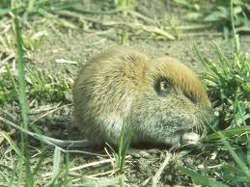  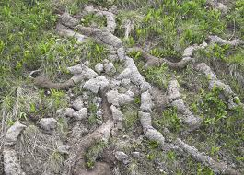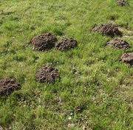 | All pocket gophers are burrowers. They are hoarders and their cheek pouches are used for transporting food back to their burrows. Gophers can collect large hoards. Their presence is unambiguously announced by the appearance of mounds of fresh dirt about 8 inches in diameter. Although they will attempt to flee when threatened, they may attack other animals, including cats and humans, and can inflict serious bites with their long, sharp teeth. Each pocket gopher inhabits its own individual tunnel system. Each litter typically consists of two to five young, although this may be much higher in some species. The young are born blind and helpless, and are weaned at around forty days.  Alfalfa and dandelions are apparently some of the most preferred and nutritious foods for pocket gophers. Damage caused by gophers includes destruction of underground utility cables and irrigation pipe, direct consumption and smothering of forage by earthen mounds, and change in species composition on rangelands by providing seedbeds (mounds) for invading annual plants. Mounds dull and plug sicklebars when harvesting hay or alfalfa, and soil brought to the surface as mounds is more likely to erode. In irrigated areas, tunnels can channel water runoff, causing loss of surface irrigation water. Gopher tunnels in ditch banks and earthen dams can weaken these structures, causing water loss by seepage and piping through a bank or the complete loss or washout of a canal bank.
Moles are small cylindrical mammals. They have velvety fur; tiny or invisible ears and eyes; and short, powerful limbs with large paws oriented for digging. Moles have been found to tolerate higher levels of carbon dioxide than other mammals. This is because their blood cells have a special and unique hemoglobin protein. Moles are able to re-use the oxygen inhaled when above ground and as a result are able to survive in low-oxygen environments such as underground burrows.  Moles have polydactyl hands; each hand has an extra thumb, next to the regular thumb. This supernumerary digit is species-specific. Moles are insectivores (they eat insects), and they may control some insect outbreaks. However, mole activity can also cause considerable damage to lawns. This damage is usually in the form of tunnels and/or mounds in lawn that can be unsightly, disturb root systems, and provide cover or travel lanes for other small mammals. | Mole  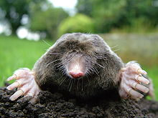  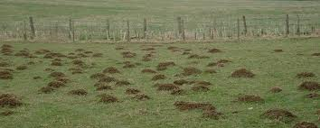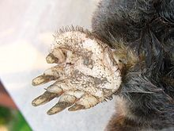
Vole  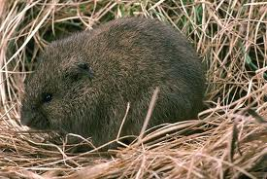  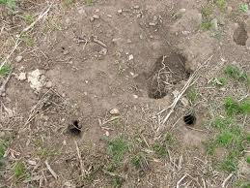  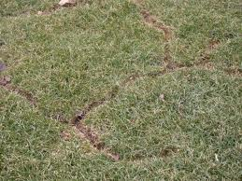 | A Vole is a small rodent resembling a mouse but with a stouter body, a shorter hairy tail, a slightly rounder head, smaller ears and eyes, and differently formed molars (high-crowned and with angular cusps instead of low-crowned and with rounded cusps). They can have 5–10 litters per year. Since litters average 5–10 young, a single pregnant vole in a yard can result in a hundred or more active voles in less than a year.  Voles will commonly use burrows with many exit holes. They will readily thrive on small plants. Like shrews they will eat dead animals and like mice or rats, they can live on most any nut or fruit. Additionally, voles will target plants more than most other small animals. It is here where their presence is mostly evident. Voles will readily girdle small trees and ground. This girdling can easily kill young plants and is not healthy for trees or other shrubs. Voles will often eat succulent root systems and will burrow under plants or ground cover they are particularly fond of and eat away until the plant is dead. Bulbs in the ground are another favorite target for voles; their excellent burrowing and tunneling gives them access to sensitive areas without clear or early warning.

