|  |
| --- |
| **2011 End of Year Report** |

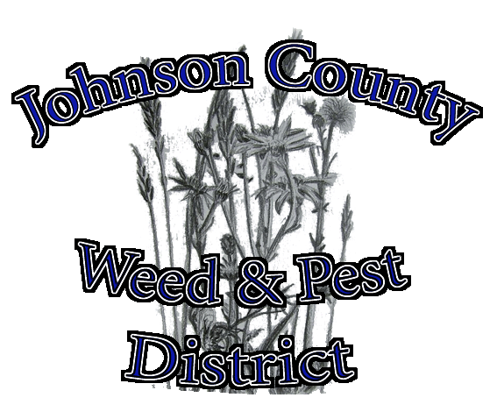

Johnson County Weed and Pest Control District

Mission and Policy

The Johnson County Weed & Pest is committed to providing leadership and education for the long term management of noxious weeds & pests through prevention, biological, cultural, mechanical and chemical controls. We are dedicated to decreasing the impacts of invasive species on native plant and animal communities, private and public lands, and local economies. The Johnson County Weed & Pest strives to have effective programs for the management of noxious weeds and pests by promoting and coordinating management and control through integrated pest management techniques, cooperation with landowners, agencies, organizations, and by providing technical expertise and educational opportunities to all within the county.

Mosquitoes – page 2

Grasshoppers – page 2

Prairie dogs - page 2

Field Certifications – page 2

Bio-control – page 2

County Roads – page 3

Wy DOT – page 3

Comped weeds – page 4

Coupons – page 4

Sprayer use – page 5

Time tracking – page 5

Application Coverages – page 6

Programs – page 7

Private Lands – page 7

BLM – page 8

State Land – page 8

Forest Service – page 8

Muddy Guard & Rock Creek Grant – page 8

**Annual Mosquito Abatement Program in the Clear Creek Drainage.**

*We apply larvacide throughout the summer to all mosquito infested water bodies from Buffalo to Ucross and in the City of Buffalo.  The larvaciding program has been very successful over the past couple of years with no impact to bees and without the invasiveness of an aerial program.  We do have ground fogging equipment, also, if needed and requested if an isolated adult outbreak occurs. In addition to the application in the Clear Creek drainage there is an available county wide cost share program on larvacide.*

|  |  |  |
| --- | --- | --- |
| County Wide Program | Income | Expenses |
| Grant | $ 20,000.00 |  |
| Donations | $ 4,175.00 |  |
| District Applied Vectobac |  | $ 13,652.01 |
| Landowner Applied Vectobac |  | $ 7,022.20 |
| District Labor |  | $ 10,269.96 |
| Mileage & Equip |  | $ 6,907.00 |
| Gas/Oil/Misc |  | $ 622.41 |
| Tire Recycling |  | $ 1,573.00 |
| Postage/Supplies |  | $ 84.92 |
| Totals | $ 24,175.00 | $ 40,131.50 |

**2011 Grasshopper Treatment and Cost Share**

Due to the apparent success of the program in 2010, Grasshopper populations warranted little spraying in 2011. The District administered a small ground treatment program for a few hot spots. The cost for control was $ 216.21 paid by landowners and the District $ 864.83 for the year.

**2011 Prairie Dog Cost Share**

|  |  |  |
| --- | --- | --- |
|  | **District** | **Landowner** |
| **53 vials of Fumitoxin** | **$ 1,298.50** | **$ 0** |
| **161 buckets of Rozol** | **$ 9,686.29** | **$ 1,320.00** |

**2011 Field Certifications**

Rod certified fields for 7 hay/straw producers in the County.

**2011 Bio Control Cost Share**

Dalmation Toadflax $ 233.00

Leafy Spurge $ 463.83

**2011 County Roads**

|  |  |
| --- | --- |
| Weeds Treated on County Roads | |
| Buffalbur | Canada thistle |
| Common burdock | Common cocklebur |
| Common mullein | Diffuse knapweed |
| Field bindweed | Houndstongue |
| Leafy spurge | Musk thistle |
| Russian knapweed | Scotch thistle |
| Puncturevine | Wild licorice |
| Whitetop |  |

|  |  |
| --- | --- |
| **2011 Co Road Cost** | |
| **Labor** | **$ 4,449.56** |
| **Herbicide** | **$ 2,287.92** |
| **Mileage** | **$ 869.00** |
| **Equipment** | **$ 5,854.40** |
| **Total Cost** | **$ 13,460.88** |

In 2011 the District treated 1,137.5 miles of county roads. Hours of labor equaled 287.5 and equipment hours were 186.8

**2011 Wyoming Department of Transportation**

The District contracts the spraying of the state highways in Johnson County to Back Country Spraying, who was awarded the bid.

**2011 County Comp**

County Comp includes spraying of county properties, cleanup on private lands and small spray jobs that do not fit in our cost share programs.

**2011 Vendor Coupon Cost Share**

|  |  |  |  |  |
| --- | --- | --- | --- | --- |
|  | **units** | **District $** | **L.O. $** | **Total $** |
| **2,4-D**  *District cost share on Designated and Declared weeds is 80/20 with the exception of Leafy spurge, the District pays 100%.* | 220.75 | 2,558.94 | 582.48 | 3,141.42 |
| **2,4-D LV6** | 2.5 | 46.93 | 11.73 | 58.66 |
| **Banvel** | 12.5 | 352.80 | 67.20 | 420.00 |
| **Chaparrel** | 37.5 | 2,142.00 | 535.50 | 2,677.50 |
| **Curtail** | 22.5 | 685.35 | 171.45 | 856.80 |
| **Escort** | 600 | 3,762.00 | 942.00 | 4,704.00 |
| **Forefront** | 100 | 3,951.01 | 988.00 | 4,939.01 |
| **Milestone** | 36.25 | 8,119.02 | 2,186.24 | 10,305.26 |
| **MSM** | 1000.0 | 3,570.12 | 900.00 | 4,470.12 |
| **Opti-Amine** | 166.000 | 1,840.68 | 893.08 | 2,733.76 |
| **Rangestar** | 3.5 | 64.86 | 15.47 | 80.33 |
| **Redeem** | 10.5 | 978.39 | 244.65 | 1,223.04 |
| **Roundup Eql** | 406 | 3,826.62 | 954.10 | 4,780.72 |
| **Telar** | 8.0 | 100.32 | 25.12 | 125.44 |
| **Tordon** | 512.59 | 14,967.52 | 4,363.94 | 19,331.46 |
|  |  | **46,966.56** | **12,880.96** | **59,847.52** |

|  |  |  |  |  |  |  |
| --- | --- | --- | --- | --- | --- | --- |
|  | **Year End Total** | | | | | |
|  | **Gallons** | **$** | **Ounces** | **$** | **pounds** | **$** |
| **2000** | 969.5 | $ 28,240.16 | 99 | $ 911.32 |  |  |
| **2001** | 821.5 | $ 27,835.46 | 48.5 | $ 480.17 |  |  |
| **2002** | 1080.65 | $ 31,673.24 | 688.5 | $ 4,838.60 |  |  |
| **2003** | 1108.5 | $ 37,755.81 | 552 | $ 4,378.80 |  |  |
| **2004** | 1160 | $ 32,933.04 | 352 | $ 3,751.68 |  |  |
| **2005** | 1518.5 | $ 45,882.36 | 224 | $ 2,352.00 |  |  |
| **2006** | 1494 | $ 55,580.79 | 144 | $ 3,012.16 |  |  |
| **2007** | 2042.5 | $ 84,479.28 | 122 | $ 1,824.24 |  |  |
| **2008** | 2605.8 | $ 99,031.29 | 1168 | $ 7,414.08 |  |  |
| **2009** | 2078.92 | $ 73,247.49 | 1776 | $ 8,143.63 | 41.25 | $ 2,918.89 |
| **2010** | 1667.75 | $ 46,668.22 | 340 | $ 1,549.20 | 23.75 | $ 1,582.50 |
| **2011** | 1494.64 | $ 37,534.66 | 1608 | $ 7,432.44 | 37.5 | $ 2,142.00 |

**2011 Sprayer use and donations**

The District has the following list of equipment for use, on a donation basis.

|  |  |  |
| --- | --- | --- |
|  | **Days Used** | **Donation** |
| **Live Trap** | 52 | $ - |
| **Backpack** | 177 | $ 80.00 |
| **150 gallon sprayer - yellow tank** | 24 | $ 30.00 |
| **50 gallon sprayer** | 5 | $ - |
| **25 g ATV sprayer** | 98 | $ 10.00 |
| **Boom Sprayer 200 g** | 23 | $ 175.00 |
| **55 g Tree Sprayer - Insecticide Only** | 5 | $ - |
| **Mosquito Fogger** | 67 | $ - |
| **Totals** | 451 | $ 295.00 |

**2011 Employees Time Spent**

**The District has assigned the following task codes in order to track were the employees time is spent. The graph includes all employees time. We also assign labor rates and track each task code for each labor rate. The total labor cost for 2011 was $ 193,654.96**

|  |  |  |  |
| --- | --- | --- | --- |
| **Code** | **Task** | **Code** | **Task** |
| **A** | Adminstrative | **L** | Leafy Spurge |
| **B** | Bonus and Holiday | **M** | Mosquito |
| **C** | County Comp Application | **O** | Office |
| **D** | Data Collection | **P** | Shop |
| **E** | Education | **Q** | Bookkeeping |
| **F** | Customer Relations | **R** | County Roads |
| **G** | GIS | **S** | Salt Cedar |
| **H** | Health | **T** | Tracking Archives |
| **I** | Incomplete day | **V** | Survey Salt Cedar |
| **J** | Personal leave | **W** | Weed Spraying |
| **K** | Kill Prairie Dogs |  |  |

**2011 Coverages – 4,817 acres treated - 84,091 acres covered**

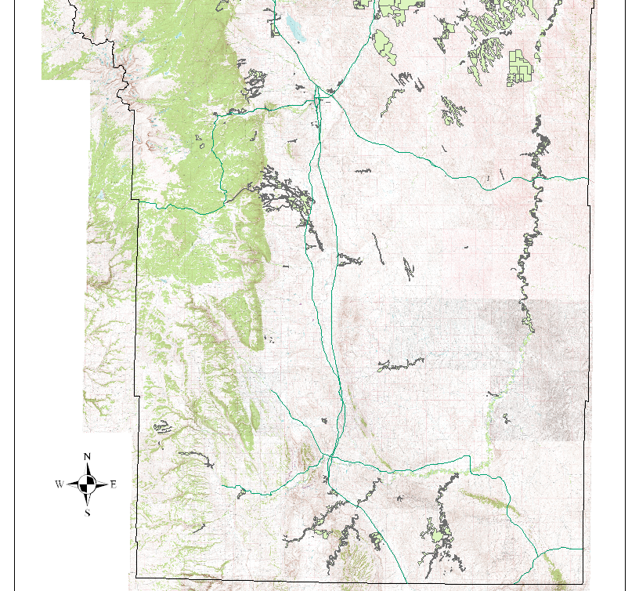

**The above map shows the acres covered by the District in 2011. 326 application records were processed during the year. The following graphs show the percentage based on acres of applicatons and program dollars.**

|  |  |  |  |  |  |
| --- | --- | --- | --- | --- | --- |
| **Private** | acres | Labor $ | Equip $ | Herbicide $ | Total $ |
| General | 571.8 | $ 8,705.23 | $ 5,180.40 | $ 9,094.96 | $ 22,980.59 |
| Leafy Spurge | 1933.2 | $ 102,787.16 | $ 717.50 | $ 23,732.83 | $ 127,237.49 |
| Salt Cedar | 1282.3 | $ 27,569.63 | $ 19,562.50 | $ 71,492.22 | $ 118,624.35 |
| **Totals** | 3787.3 | $ 139,062.02 | $ 25,460.40 | $ 104,320.01 | $ 268,842.43 |

**Government Agencies**

**2011 Bureau of Land Management**

|  |  |  |  |  |  |
| --- | --- | --- | --- | --- | --- |
| **BLM** | acres | Labor $ | Equip $ | Herbicide $ | Total $ |
| General | 40 | $ 4,014.63 | $ 1,101.25 | $ 513.26 | $ 5,629.14 |
| Leafy Spurge | 107 | $ 12,357.22 | $ 61.00 | $ 2,328.76 | $ 14,746.98 |
| Salt Cedar | 84.5 | $ 4,732.70 | $ 525.00 | $ 5,131.82 | $ 10,389.52 |
| **Totals** | 231.5 | $ 21,104.55 | $ 1,687.25 | $ 7,973.84 | $ 30,765.64 |

**2011 State Lands**

|  |  |  |  |  |  |
| --- | --- | --- | --- | --- | --- |
| **State** | acres | Labor $ | Equip $ | Herbicide $ | Total $ |
| General | 17 | $ - | $ - | $ 323.80 | $ 323.80 |
| Leafy Spurge | 443 | $ 26,200.00 | $ 1,584.40 | $ 5,101.39 | $ 32,885.79 |
| Salt Cedar | 134 | $ 3,940.03 | $ 1,127.00 | $ 6,950.45 | $ 12,017.48 |
| **Totals** | 594 | $ 30,140.03 | $ 2,711.40 | $ 12,375.64 | $ 45,227.07 |

**2011 Forest Service**

|  |  |  |  |  |  |
| --- | --- | --- | --- | --- | --- |
| **Forest Service** | acres | Labor $ | Equip $ | Herbicide $ | Total $ |
| General | 25 | $ 5,969.27 | $ 599.00 | $ 445.05 | $ 7,013.32 |
| Leafy Spurge | 8 | $ 1,883.62 | $ 178.50 | $ 161.28 | $ 2,223.40 |
| **Totals** | 33 | $ 7,852.89 | $ 777.50 | $ 606.33 | $ 9,236.72 |

**2011 Muddy Guard Grant and Rock Creek Grant**

|  |  |  |  |  |  |  |  |  |  |
| --- | --- | --- | --- | --- | --- | --- | --- | --- | --- |
| **Muddy Guard Grant** | acres | District $ | L.O. $ | Grant $ | **Rock Creek Grant** | acres | District $ | L.O. $ | Grant $ |
| Crazy Woman Ranch | 26 | 1,529.42 | 382.36 | 1,290.00 | Bud Love | 10 | 0.00 | 0.00 | 1,186.74 |
| Crossingham | 12 | 897.09 | 224.27 | 780.00 | Steerhead | 23 | 1,356.07 | 339.02 | 813.26 |
| Leitchman | 1 | 121.86 | 30.47 | 90.00 | **Totals** | 33 | 1,356.07 | 339.02 | 2,000.00 |
| LZ Ranch | 4 | 321.26 | 130.32 | 450.00 |  |  |  |  |  |
| Neltje | 5 | 462.02 | 115.50 | 390.00 |  |  |  |  |  |
| **Totals** | 48 | 3,331.65 | 882.92 | 3,000.00 |  |  |  |  |  |

**Johnson County Weed and Pest Control District**

**www.jcweedandpest.com**